

HOW2 IMPROVE YOUR MEMORY TECHNIQUES
(LSD5)

STUDENT COUNSELLING, CAREER
AND DEVELOPMENT CENTRE

Summerstrand Campus (North) Tel: 041 504 3222

2nd Avenue Campus Tel: 041 504 3854

Summerstrand Campus (South) Tel: 041 504 2511

Vista Campus Tel: 041 408 3106

George Campus Tel: 044 801 5051

Understanding how memory operates can help you to develop effective learning techniques.

Memory consists of the following 3 aspects:
1. Registration of information. This refers to the process of
absorbing information i.e. taking it in.
2. Retention of information. This refers to the process of retaining information in your memory i.e. keeping it in your head.
3. Retrieval of information. This refers to the process of accessing information when you are reviewing material and when writing tests and exams i.e. getting it out.

TECHNIQUES TO ENHANCE MEMORY

1 Registration of information

- Adopt a positive attitude that you can and will remember even if it takes a long time and a lot of effort.

- Develop an interest in what you are studying. Try to find reasons to be interested in the topic. Immerse yourself in the topic. Read other texts on the subject.

- Give your full attention to what you want to learn. Practice focusing your concentration. (Refer to pamphlet SS3: How2 improve your concentration.) Find a quiet place to study that is free from distractions.

- Decide on the time period and on the amount of work you want to learn e.g. 19:00 – 19:50: Go over English lecture. (Refer to pamphlet SS1: How2 manage your time.)

- Read actively. Don’t simply stare at the page. Always read with a pencil in your hand. Mark information.

- Visualise relationships. Create pictures about things you are studying. Draw diagrams. Make cartoons. Turn abstract ideas into concrete actions or illustrations. Make these visualisations interesting, colourful and humorous. We remember things that are entertaining and funny far more easily!

- Read aloud (or under your breath) to check if you understand what you are reading. Repeat the information in your own words. Exaggerate words, use actions, etc.

- Attempt to make connections between new information and existing knowledge so that you understand what you are learning.

- Learn from the general to the specific. Get a broad overview of the subject before you begin to learn the details.

- Calculations need to be practiced regularly. Number-work requires a different style of memory. Make sure that you understand formulas, technical terms, definitions, etc. and then apply this knowledge. This can be done by going over previous work given for homework and also by working through test papers. These questions and correct answers can be used as a frame of reference while studying these understanding and practical application subjects.

2 Retention

- Periodic repetition will help you retain information.

- Practice writing information. The sight of the information will give you confidence that you are retaining the knowledge. Writing information will draw your attention to what needs to be re-learned.

- Make use of Mnemonics such as:

  - Acronyms
These are words created by the first letters of a series of words. Use the first letter of each word that you want to remember (i.e. keyword), to form a word or words. For example you want to remember five goals for counselling:

1) Spontaneity
2) Trust
3) Awareness
4) Independence
5) Responsible action

The word STAIR holds the association that is necessary to recall these five facts.

  - Creative sentences
This involves creating a sentence where the first letter of each word represents something to be remembered.
For example, “Every good boy does fine.” This helps music students to recall the notes of the treble clef staff.

  - Rhymes and songs
For example, “In fourteen hundred and ninety two Columbus sailed the ocean blue.”

- Visual Reminders
Create lists, summaries, charts, mind maps, etc. and stick them in visible places, for example, on your bedroom mirror. Change the charts periodically so that you are constantly stimulated by the information. Two examples of visual reminders are point-form summaries and mind maps.

  - Point-form summaries
Here is an example of a point-form summary of Steps in Study.
STEPS IN STUDY

1. Start studying by:
  - anchoring
  - writing down thoughts (e.g. worries and
frustrations)
  - relaxation exercise

- Plan
  - Time?
  - Break into chunks

3. Environment
3.1 Pleasant

4. Preparation
  - Baroque music

  - Relaxation
  - Positive thinking

5. Study
  - 20 – 45 minutes
  - Brain maps
  - Visualization

6. Break
  - 2 – 10 minutes
  - Physical exercise/chores/dancing/do something
else

7. Test
  - Say or write
  - Check recall

8. Repeat process
  - Study
  - Break
  - Test

9. Revise
  - Now
  - In a day’s time
  - In a week’s time
  - In a month’s time

  - Mind maps
Mind maps are a useful aid for recalling information.
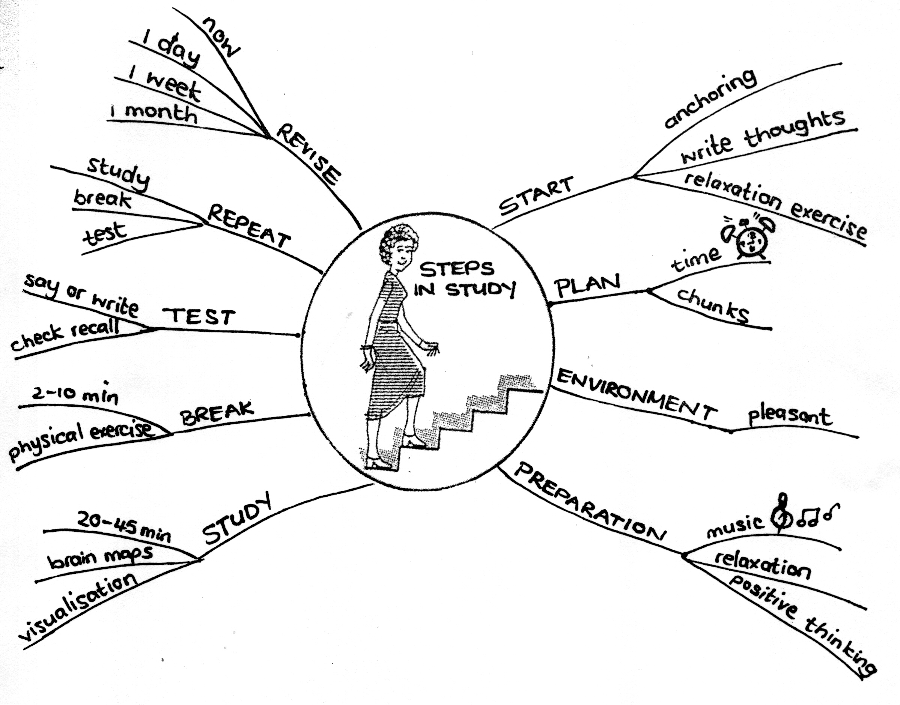
Research has shown that this is one of the most effective ways of making a summary. The mind map organizes material in a way that makes it easier to understand and remember. Here is an example of a mind map summary of Steps in Study.

Rules regarding mind maps

- Draw something or make an image which would represent the central subject, for example, a woman climbing stairs to represent the steps in studying. Write word/s representing the subject in the centre, using capital letters. The central image should be colourful.

- Draw the spikes clockwise, starting at the 1 o’clock position, using different colours for main points and sub-points.

- Major ideas are written down on spikes coming from the centre, for example, START, PLAN, ENVIRONMENT, etc. These lines must be connected to the centre and should not hang in the air.

- Words are printed. The brain reads the printed word more easily.

- The words must be on the lines and should not hang off the ends of the lines. Why? Writing the words on the line, will enable you to remember them better.

- Make images or pictures in the mind map, for example, if one point is about time, draw a clock.

- The main points, stemming from the central point are printed in upper case (capital letters) and the secondary, tertiary, etc. points in lower case (small letters).

- All the lines should touch (be connected). This enhances your ability to remember associations between facts.

- Experts recommend that single words only should be used

3 Retrieval

Here are some techniques to enhance retrieval

- Practice retrieving information – bring it into consciousness from time to time. (Refer to pamphlet SS4: How2 learn.)
- Remember something else. When you are unable to remember something, recall facts that are related to the one you are having trouble with. Similar information is stored in the same area of the brain. You can unblock your recall by stimulating that area of your memory. It may be helpful to jot down associated ideas.

- Practice writing information. Writing can give you confidence and help you to generate ideas.

- Draw diagrams/pictures. The action of putting pen to paper could help you to come up with ideas.

- Picture/visualize everything to do with the topic. For example, the layout of the pages, when you learnt it, what the lecture sounded like, what efforts you made to learn it, etc.

- Relax. If you over-intensify your efforts to recall material, you take the risk of blocking off completely. A relaxed mind functions more effectively. (See pamphlet SS7: How2 manage test and exam anxiety)

NOTE: There is NO single method which works for all students. It is recommended that you try the different techniques described in this booklet (and in other literature on learning) and attempt to find the approach that suits you. Be prepared to acknowledge honestly if your approach is not working and then make some changes to your study techniques. Consult a Student Counsellor for further assistance.
BIBLIOGRAPHY

Bransby, J. (1990). Effective Study. Port Elizabeth: J. Bransby.

Ellis, D.B. (1985). Becoming a master student. Rapid City; College Survival, Inc.

Grove, S. (1993). Thank You, Brain. Cape Town: Human & Rousseau.

Material from Study workshops compiled by Department Student Counselling, Port Elizabeth Technikon.

Pamphlets in the series ‘How to pass your Exams Easily,’ by Counselling & Career Development Centre, Technikon Natal.

